**CHAPTER II**

**METHODOLOGY OF THE STUDY**

For this study, the proponents used a modified waterfall model process. This process is consisting of six (6) different categories that are set to meet each requirement to finish the project.

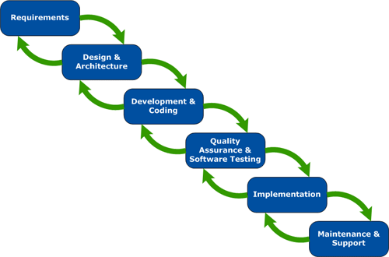

Figure 1. Modified Waterfall Model

**Requirement**

The proponents look for and analyse the possible solution for the problem of the company so that the proponents will solve their problems encountered and most important is the specification which is needed to identify the minimum requirements where the system can run smoothly and productivity. The proponents identified the possible goals of the proposed system which can help the company to their business process.

**Design and Architecture**

In this phase, the proponents began to build a prototype of the system and its model structures for the template and photo editing app to make some changes. The making of Context Diagram, Data Flow Diagram and Entity Relationship Diagram happen here; the proponents designed these diagrams so that it will become the basis in the system. Included, in this phase were the designing of the database structure, schematic structure and the User Interface. In this phase, it helps in specifying hardware and system requirements and helps in defining the overall system architecture.

**Development and Coding**

After the designing phase, the system design id forwarder to the programmer and begin to code in order to meet the specific objectives of the being stated by the proponents. Codes is a highly important to represents the total functionality of the system.

**Quality Assurance and Software Testing**

In this phase, the proponents will test the system to ensure if it has a problem to fix or issues within the application that need to be resolved. In testing the functionalities of the system, the proponents will conduct the black box testing, that the system achieves its objectives. The proponents will also the usability, maintainability, and portability of the system. And it belongs here the verification of the program for implementation and deployment.

**Implementation**

After testing, the product or process is implemented. The implementation should be done in compliance with all prevalent industry-specific guidelines and regulations and or organizational guidelines.  Post implementation verification and testing must be carried out to ensure the final implementation is successful.

**Maintenance**

After the final product is delivered to the client, maintenance service is provided to make sure that the product or the service keeps on performing as expected. The maintenance period is usually for a specified and agreed period of time.